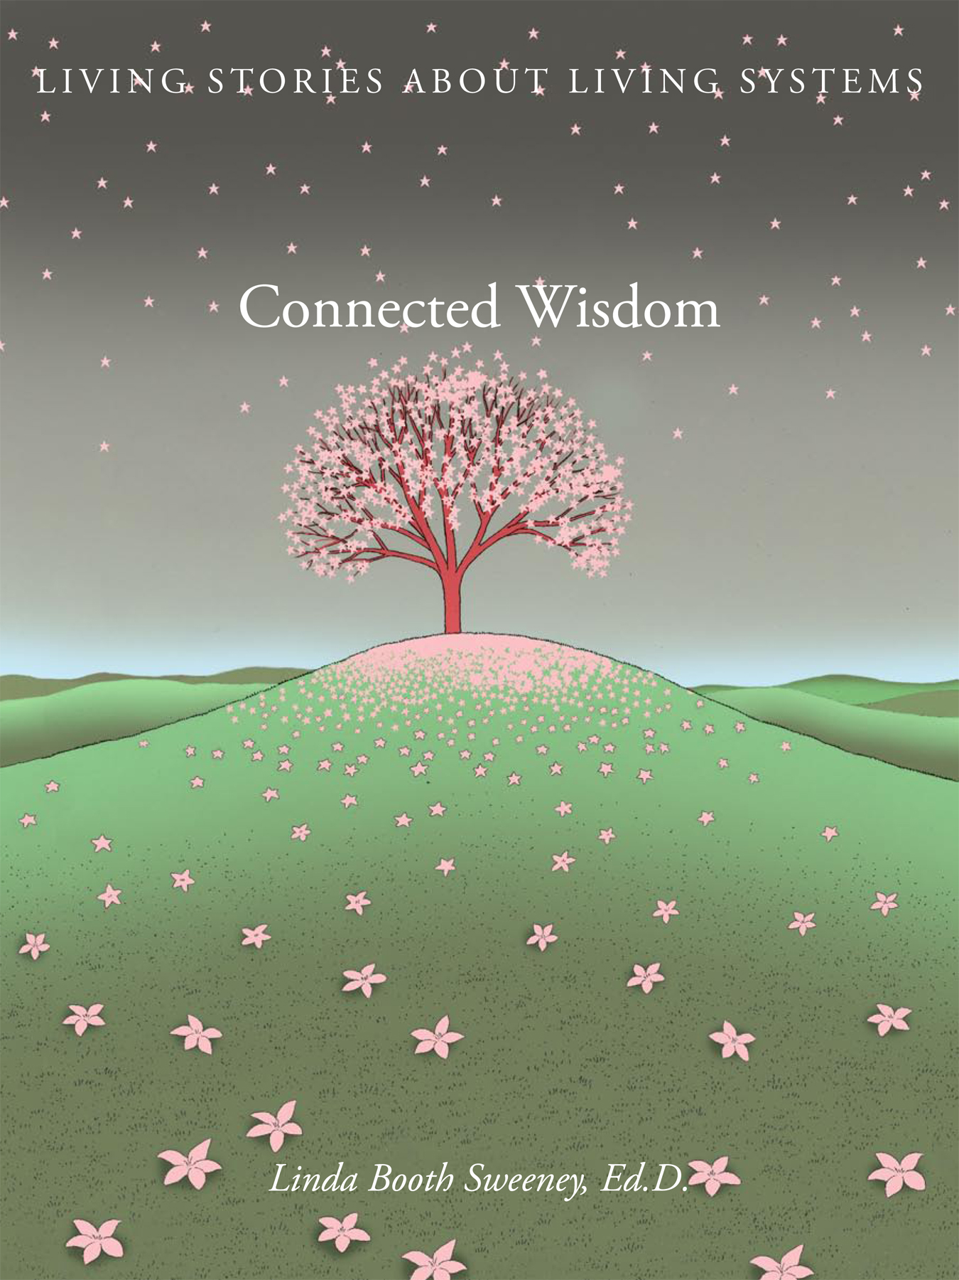
Advance Praise for

CONNECTED WISDOM:
LIVING STORIES FOR LIVING SYSTEMS

by Linda Booth Sweeney, Ed. D.
Art Direction by Milton Glaser Inc.
Illustrations by Guy Billout
Published by SEED and distributed by Chelsea Green

"The moment you touch and open this book, its wisdom is evident. This is the wisdom of wholes, of belonging, and connecting the dots to see the richer tapestry of life."
-- Raffi ~ singer, author, founder of Child Honoring

“Bravo! Your book is a triumph. Connected Wisdom: Living Stories about Living Systems belongs in every classroom.”
-- Joanna Macy, Eco-philosopher, author, and educator

Connected Wisdom is spectacular -- mouth watering! I love the simplicity of
language [the author] uses to tell the stories, and the framing of them. The artwork
is delightful and the book design and materials are knock-your-socks off.
-- Anne Starr, Partner, The Learning Circle

“As our new century unfolds, it is becoming more and more evident that the major problems of our time are systemic problems, which means that they are all interconnected and interdependent. To solve them, we need to learn how to think systemically — in terms of relationships, patterns, processes, and context. In this book, Linda Booth Sweeney has assembled a wonderful collection of ancient folk tales and myths from around the world, which convey the profound "systemic wisdom" of peoples who lived close to nature and had a deep intuitive understanding of life's networks, cycles, and processes of transformation. I highly recommend Connected Wisdom as a superb tool for teaching and learning the systemic thinking that is critical in our globally interconnected world.”
-- Fritjof Capra, author, The Web of Life and The Hidden Connections

Praise for Connected Wisdom / 2

“A beautiful book of beautiful stories for a new generation of system citizens. Milton Glaser's art design, Guy Billout’s illustrations and the timeless stories remind us of what beauty can teach and the wisdom of cultures who have come before us. An aesthetic milestone of the systems movement.”

-- Peter M. Senge, MIT and SoL. author or co-author of The Fifth Discipline, Presence, and The Necessary Revolution “

Artfully, beautifully, playfully, seriously, clearly Linda Booth Sweeney invites us to join her in a deeper understanding of the profound principles of living systems. Tapping wisdom connected to many cultures and many times, Linda weaves memorable simple stories into a tapestry holding enormous complexity. A book that is at once a work of art, a representation of science, and an invitation to think more deeply and playfully, Connected Wisdom is a gift. Whether the reader is six or sixty, it matters not. These pages open us more fully to the world around us.
-- Judy Sorum Brown,
Poet and Leadership educator
Senior Fellow,
The James MacGregor Burns Academy of Leadership
A gorgeous collection of fables, illuminated by thoughtful summaries. Connected Wisdom gives us a clear view of living systems through the power of storytelling. My first glance gave me that ever-warming Aha! of interconnectedness.”
-- Peter C. Stone, author of The Untouchable Tree, An Illustrated Guide to Earthly Wisdom & Arboreal Delights
So well presented, so clearly written, so enticing to the teacher in me, so appealing to the self-directed learner. I love the way [Linda Booth Sweeney] connects classic folk tales to what's real for students (of any age) and to the larger context of natural systems. She prepares the reader for each tale such that we marvel at the universality of the spoken traditions of old…. I have only one stumbling block about this book: I always read with a pencil in hand - to mark meaningful phrases and ideas that I will want to refer to in a second or third reading. Connected Wisdom is so beautiful that I've not been able to mark it up... yet. I find myself imagining what I'd do were I still in the classroom to use these tales in an integrated way, to inspire and promote problem solving and systems thinking in student groups. In the book, there are things I'd hold back from students because I think they'd love making the connections on their own, with the proper prep and the literature as a prompt.

If education can make the adjustment to a systems approach that is inclusive of environmental science and human relatedness as she suggests, we'll be far better off. I think the days of independence and self-centered thinking are over. We need a holistic approach to living and learning where teachers and children, families and communities, farmers and white-collar workers respect each other and depend on each other for the sustainability of the planet. ”
-- Sandria Parsons, Founder, South Coast Learning Network

“I just received your beautiful book! .... It's wonderful to see how you can make the ideas resonate--presenting them in a straightforward way that gets to their essential elements. And the illustrations by Guy Billout are a great accompaniment, curiously detailed and mythic at the same moment. Congratulations.”
-- David Eddy Spicer, University of Bath (UK), Department of Education
“Our actions, connected to the people and the natural world around us, are not only worth seeing, it is the point at which you are actually seeing. Connected Wisdom uses simple language, pictures, and parables to explain and beautifully illustrate natural principles in our relationships to each other and the natural world. This book helps parents and children alike see our world made up of many parts for what it is – connected.”
-- Steve Swenson, Aldo Leopold Foundation

”Beautiful …. The writing so seamlessly tied together [the author’s] ecological concepts with the stories … chosen. And such handsome bookmaking! I am doing a keynote on tales of kindness for the National Storytelling Network Conference in Hawaii and will add this to my bibliography.”
-- Margaret Read MacDonald, Author and storyteller
”Wow! I love how [Linda Booth Sweeney] talks about each concept and uses the folktales to illustrate/expand. The book could easily be used as the basis for a
curriculum on the interconnected-ness of our world (in a variety of content
areas from science to social studies)--the concepts can be talked about and
applied at so many different levels. I feel like it could be adapted and
used in the whole range of grade levels--kindergarten through high school.”
-- Rachel Rosner, Professional Educator

“The book itself is a delight, both beautifully presented and illustrated. We share this belief in the power of story-telling and all at once I was struck with the simplicity and power of the book. Children (and adults) are able to take key messages from these stories, greatly enhancing their understanding of the interconnectedness of our world, but without feeling overwhelmed by the complexity of the concepts. I love the fact that the stories have been carefully selected from so many different cultural backgrounds; perfect for the international school setting.”
-- Nik Bishop-former head of the British School of Nanjing (soon-to-be head of the International School in Malawi)

